- Illustrating Life Cycle of a Thread
Write a Java program to create a thread and demonstrate its life cycle states such as New, Runnable, Running, Waiting/Blocked, and Terminated using appropriate thread methods such as start(), sleep(), and join(). Display suitable messages to show the state transitions.
public class Main {

static class MyThread extends Thread {

public void run() {
System.out.println("Thread is now RUNNING.");

try {
System.out.println("Thread is going to SLEEP...");
Thread.sleep(1000);

System.out.println("Thread is RUNNABLE again.");
} catch (InterruptedException e) {
System.out.println(e);
}

System.out.println("Thread execution completed.");
}
}

public static void main(String[] args) throws Exception {

MyThread t = new MyThread();

// NEW state
System.out.println("1. Thread State: " + t.getState());

// Start thread
t.start();

// RUNNABLE state
System.out.println("2. Thread State after start(): " + t.getState());

// Main thread waits for child thread
t.join();

// TERMINATED state
System.out.println("3. Thread State after join(): " + t.getState());

System.out.println("Thread Life Cycle Completed.");
}
}
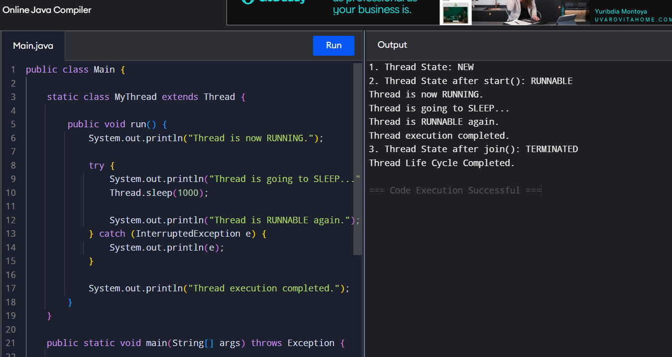
- Thread Priorities
Write a Java program to create three threads representing High, Medium, and Low priority tasks. Assign different priorities using setPriority() and execute the threads. Display the thread name and priority during execution to illustrate the effect of thread priorities.
public class Main {

static class MyThread extends Thread {

MyThread(String name, int priority) {
super(name);
setPriority(priority);
}

public void run() {
for (int i = 1; i <= 5; i++) {
System.out.println(
getName() + " - Priority: " + getPriority()
+ " - Execution: " + i
);

try {
Thread.sleep(100);
} catch (InterruptedException e) {
System.out.println(e);
}
}
}
}

public static void main(String[] args) throws Exception {

MyThread low = new MyThread("Low Priority Task", Thread.MIN_PRIORITY);
MyThread medium = new MyThread("Medium Priority Task", Thread.NORM_PRIORITY);
MyThread high = new MyThread("High Priority Task", Thread.MAX_PRIORITY);

low.start();
medium.start();
high.start();

low.join();
medium.join();
high.join();

System.out.println("All threads completed.");
}
}
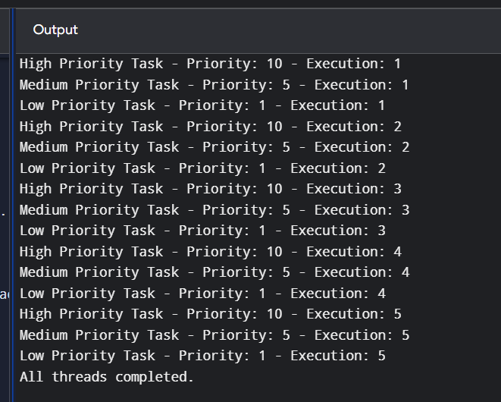
- Synchronized Method
Write a Java program to simulate a bank account accessed by multiple threads. Create a deposit() and withdraw() operation using a synchronized method so that multiple threads cannot modify the account balance simultaneously. Display the final account balance.
public class Main {

static class BankAccount {

int balance = 1000;

synchronized void deposit(int amount) {
balance = balance + amount;

System.out.println(
Thread.currentThread().getName()
+ " deposited Rs." + amount
+ " | Balance = Rs." + balance
);
}

synchronized void withdraw(int amount) {

if (balance >= amount) {
balance = balance - amount;

System.out.println(
Thread.currentThread().getName()
+ " withdrew Rs." + amount
+ " | Balance = Rs." + balance
);
} else {
System.out.println(
Thread.currentThread().getName()
+ " cannot withdraw Rs." + amount
+ " | Insufficient Balance"
);
}
}
}

static class DepositThread extends Thread {

BankAccount account;

DepositThread(BankAccount account) {
this.account = account;
}

public void run() {
account.deposit(500);
}
}

static class WithdrawThread extends Thread {

BankAccount account;

WithdrawThread(BankAccount account) {
this.account = account;
}

public void run() {
account.withdraw(300);
}
}

public static void main(String[] args) throws Exception {

BankAccount account = new BankAccount();

Thread t1 = new DepositThread(account);
Thread t2 = new WithdrawThread(account);
Thread t3 = new WithdrawThread(account);

t1.setName("Deposit Thread");
t2.setName("Withdraw Thread 1");
t3.setName("Withdraw Thread 2");

t1.start();
t2.start();
t3.start();

t1.join();
t2.join();
t3.join();

System.out.println("Final Account Balance = Rs." + account.balance);
}
}
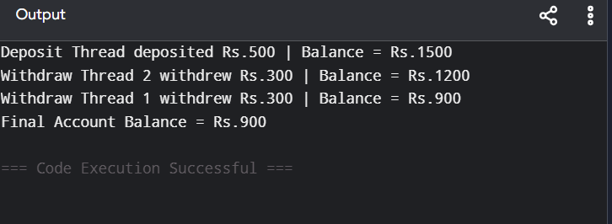
- Synchronized Block
Write a Java program to simulate ticket booking where multiple threads attempt to book tickets simultaneously. Use a synchronized block to ensure that only one thread can access the critical section at a time. Display the booking details and remaining tickets.
public class Main {

static class TicketBooking {

int tickets = 5;

void bookTicket(int number) {

synchronized (this) {

System.out.println(
Thread.currentThread().getName()
+ " is trying to book " + number + " ticket(s)."
);

if (tickets >= number) {

System.out.println(
Thread.currentThread().getName()
+ " is booking tickets..."
);

try {
Thread.sleep(500);
} catch (InterruptedException e) {
System.out.println(e);
}

tickets = tickets - number;

System.out.println(
Thread.currentThread().getName()
+ " successfully booked " + number
+ " ticket(s)."
);

System.out.println(
"Remaining Tickets = " + tickets
);

} else {

System.out.println(
Thread.currentThread().getName()
+ " - Not enough tickets available."
);
}
}
}
}

static class BookingThread extends Thread {

TicketBooking booking;
int number;

BookingThread(TicketBooking booking, int number, String name) {
this.booking = booking;
this.number = number;
setName(name);
}

public void run() {
booking.bookTicket(number);
}
}

public static void main(String[] args) throws Exception {

TicketBooking booking = new TicketBooking();

Thread t1 = new BookingThread(booking, 2, "Customer 1");
Thread t2 = new BookingThread(booking, 2, "Customer 2");
Thread t3 = new BookingThread(booking, 2, "Customer 3");

t1.start();
t2.start();
t3.start();

t1.join();
t2.join();
t3.join();

System.out.println(
"Final Remaining Tickets = " + booking.tickets
);
}
}
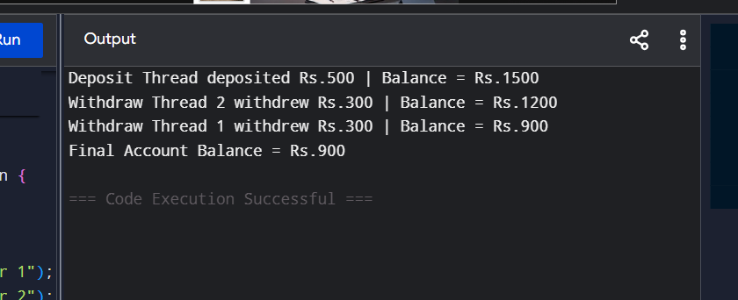
- Static Synchronization
Write a Java program to simulate a shared college examination counter accessed by multiple threads created from different objects of the same class. Use static synchronization to ensure that only one thread at a time can update the shared counter. Display the counter value after all threads complete.
public class Main {

static class ExamCounter {

static int counter = 0;

static synchronized void updateCounter() {

counter++;

System.out.println(
Thread.currentThread().getName()
+ " updated counter to: " + counter
);

try {
Thread.sleep(200);
} catch (InterruptedException e) {
System.out.println(e);
}
}
}

static class StudentThread extends Thread {

StudentThread(String name) {
setName(name);
}

public void run() {

for (int i = 1; i <= 2; i++) {
ExamCounter.updateCounter();
}
}
}

public static void main(String[] args) throws Exception {

StudentThread t1 = new StudentThread("Student Thread 1");
StudentThread t2 = new StudentThread("Student Thread 2");
StudentThread t3 = new StudentThread("Student Thread 3");

t1.start();
t2.start();
t3.start();

t1.join();
t2.join();
t3.join();

System.out.println(
"Final Examination Counter = "
+ ExamCounter.counter
);
}
}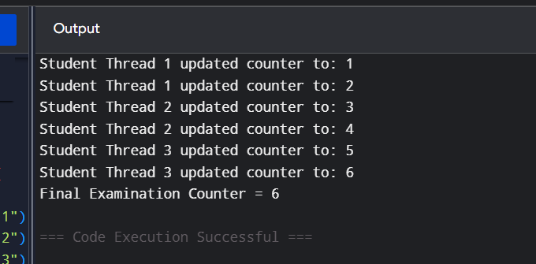
- Inter-Thread Communication
Create Customer class with deposit() and withdraw() as synchronized methods. Declare AccountNo, AccName and Balance as Instance Variables inside the class. From the main class, Input the amount for withdraw() operation and if requested amount is not available in existing Balance amount, withdraw() method should be temporarily suspended using wait() method until deposit() method receives the input for amount, to be added in the existing Balance amount and then withdraw() would be completed in a successful manner. Develop the above scenario using Synchronization and Inter-Thread Communication.
import java.util.Scanner;

public class Main {

static class Customer {

int AccountNo;
String AccName;
int Balance;

Customer(int AccountNo, String AccName, int Balance) {
this.AccountNo = AccountNo;
this.AccName = AccName;
this.Balance = Balance;
}

synchronized void withdraw(int amount) {

System.out.println(
"Withdrawal request: Rs." + amount
);

while (Balance < amount) {

System.out.println(
"Insufficient balance."
);

System.out.println(
"Withdrawal thread is WAITING..."
);

try {
wait();
} catch (InterruptedException e) {
System.out.println(e);
}
}

Balance = Balance - amount;

System.out.println(
"Withdrawal successful: Rs." + amount
);

System.out.println(
"Remaining Balance = Rs." + Balance
);
}

synchronized void deposit(int amount) {

System.out.println(
"Deposit operation started..."
);

Balance = Balance + amount;

System.out.println(
"Deposited: Rs." + amount
);

System.out.println(
"Updated Balance = Rs." + Balance
);

notify();
}
}

public static void main(String[] args) throws Exception {

Scanner sc = new Scanner(System.in);

Customer customer =
new Customer(101, "Roshitha", 1000);

System.out.println("Account Number: " + customer.AccountNo);
System.out.println("Account Name: " + customer.AccName);
System.out.println("Existing Balance: Rs." + customer.Balance);

System.out.print("Enter withdrawal amount: ");
int withdrawAmount = sc.nextInt();

Thread withdrawThread = new Thread(() -> {
customer.withdraw(withdrawAmount);
});

Thread depositThread = new Thread(() -> {

try {
Thread.sleep(2000);
} catch (InterruptedException e) {
System.out.println(e);
}

customer.deposit(1000);
});

withdrawThread.start();
depositThread.start();

withdrawThread.join();
depositThread.join();

System.out.println(
"Final Balance = Rs." + customer.Balance
);

sc.close();
}
}
